IT20028732 DL_Lab4

**Face Verification Results (Name in images dataset is : ’you’)**



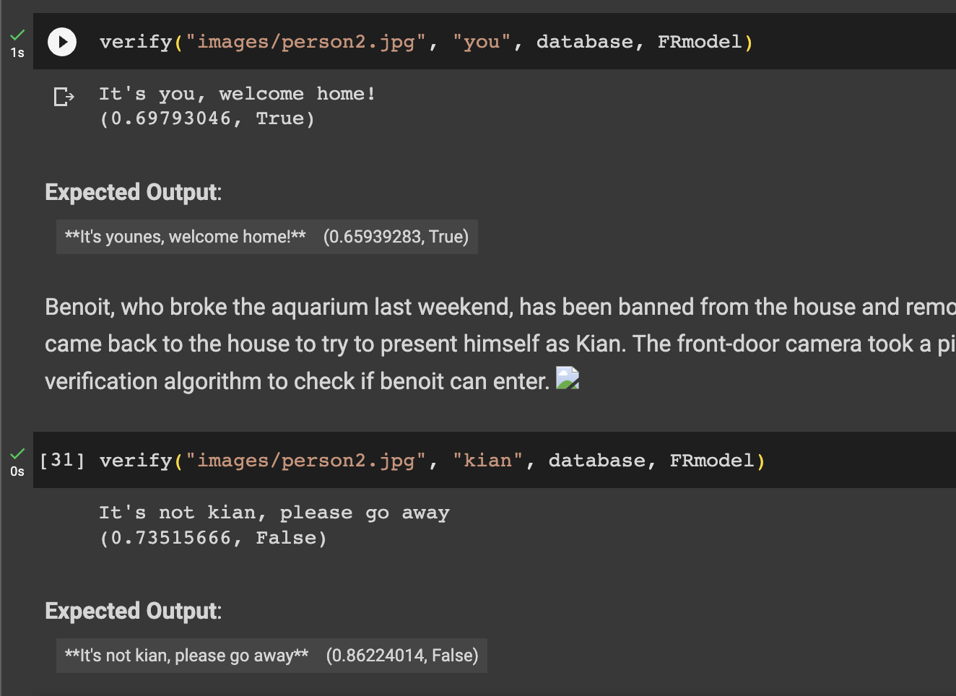

**Face Recognition results**

